**SEHH3143​**

**Group ID​**

**201A-G04**

**Marble Cart Noodles​**

**Online Food Ordering and Delivery Services ​**

[**https://www.youtube.com/watch?reload=9&v=ptgciAlOfyA**](https://www.youtube.com/watch?reload=9&v=ptgciAlOfyA)

|  |
| --- |
|  |
|  |
|  |
|  |
|  |
|  |

1. **Requirements Specification:**
2. **The current problems or limitation**
3. **The order may get wrong.**

The food is not what the customers ordered, or the delivery address is not correct. For an example, “13/F” should be “15/F”, but the staff jot the notes is messy write 15 rather than 13, so that it makes the deliveryman cannot deliver the food to the right address.

1. **Unknown delivery address.**

The deliveryman may not know the delivery address, so that they may need to spend the time on searching the location of the buildings.

1. **Unable to server more than one customer.**

There is only a customer can order the food by phone calling at the same time.

1. **Spending double time to order the food.**

The staff need jot notes after the customers tell him/her that they would like to order.

1. **Paying cash is the one and only way.**

The customers can only pay the cash to the deliveryman.

1. **The new promotions are hard to attract the customers.**

The customers cannot get the latest information like promotion, discount and change of the opening hours unless they go to the restaurant.

1. **It is inconvenient to change the menu.**

It is hard to design the menu which is clear and easy to read when there are a wide range of items and price. It is hard for the customer to read the menu without sorting.

1. **Unknown arriving time.**

The customers never know the arriving time of the delivery. It makes the customers keep waiting for the food after they ordered the food.

1. **The customer may not choose the nearest restaurants.**

The customer may not order the food form the nearest restaurant; it makes the deliveryman need to spend more time to deliver the food. For an example, the delivery address is near Tsuen Wan, delivering the food form the restaurant in Tsuen Wan instead of the restaurant in Kwai Fong can save a lot of time and costs.

1. **Objectives of the proposed system**

For the existing mainstream system, apparently there are some omissions that would cause inefficient and restricted problems, those would lead to customers and employee dissatisfaction. Our requirement is going to solve the currently problems illustrated in above. The currently functions of the application are aimed to associate both customer, vendor and deliveryman in one structure, performing a complete takeaway system. In overall business requirements, reduce the operating time and promote the turnover the for the company which are the objectives that we must achieve. In the system, by implementing the simplicity progress for the users, it can reduce the operating time. Besides, there are analyzation in the application, it assists the company to determine the future strategies and objectives.

1. **Functional and non-functional requirements of the proposed system**
2. **Functional requirements**

**Main page:**

* Choose login or sign in

There are two buttons to let user to choose which options login or sign in the system.

* Change languages

In the right top corner to let the user to change the languages to English or Chinese.

**Customer:**

* Register

After user press register. There has a page for user to choose Facebook/Google/MeWe these account for user to register conveniently or user can use the traditional way email address to register. After the register finished. The system will send a confirming email to user’ email. And the link only effective in two weeks.

* Passwords

In the page of signing in, there have the password and confirm password bar like all the website when user sign in. When the user inputs the password or confirm password, the input words will transform into stars. It is an appropriate way to protect user passwords. Also, the password word must have at least one upper case and one lower case or number and at least six character.

* Type of account

After user input all their name, passwords, email, user can choose the what type of account they want. The system provides the courier and customer two options for user.

* Login

When the login in, user can choose Facebook/ Google / MeWe / email account to login. After user login in, the page will show all the category of restaurants provides.

* Forgetting passwords

The system provides forgetting passwords. After inputting the email what they registered, the password reset link will send back to the user email the link will be available in two weeks.

* Head Buttons
* Home button

In top center is a home button when user press this will return the main menu page.

* Shopping cart

Right top corner is a shopping cart button, user can check the price and the items they choose and check the order. Also, in the shopping cart icon will show the number of items user added in the cart.

* Multi-functional menu

In left top corner, it is a multi-functional menu. The user can choose my favorite, order records, personal information, address, payment method, coupons, customer service, inviting friends, reviews, setting, Terms and Conditions and logout. Also, display the user icon.

* Menu

Display the menu supply and it can be changed id the food is valid or not.

* Buying function

User can add the food they want to order or cancel the food also each of the item have a heart, when user presses the button, the items will add in my favorite page.

* Searching bar and Filter button

The user can type the food name they want. Also, they can use the voice function to search for. Also, the system can record what user searching before and cancel the records. The system can show other hot searching words too. After searching a word, the result will show all the result according to the user input. After searching, there is a filter button, user can choose the price, rating and time these factors to sort.

* My favorite page

If the favorite is empty, it will display message that “You don’t have any favorite.” under the message will a button to show explore more once it pressed it will back to home page. If it has favorite food, it will display the favorite food also with the price, rating and the delivery time.

* Order records

If user don’t have any orders, it will display message that “You don’t have any orders.” under the message will a button to show explore more once it pressed it will back to home page. If it has orders, it will display the orders and once it pressed it will display more detail of the orders.

* Personal information

User can change the first name, last name, email address, phone number and password anytime. Below this contact information is a saving button.

* Address

If the address is empty, it will display message that “You don’t have any address.” under the message will have a button to add new address then user to input their address. If it has address, it will display the address also the user can edit the address.

* Payment method

If the payment method is empty, it will display message that “You don’t have any payment method.” under the message will have a button to add new payment method then user can choose to add which payment method credit card or PayPal then input their payment method. If it has payment method, it will display the payment method also the user can edit the payment method or delete or add more payment method.

* Coupons

If the coupon is empty, it will display message that “You don’t have any coupons.” Under the message, there is a button to add a coupon. The user can input the code of the coupon and send it out. After the user send the code of the coupon. There will be a message show” you have added a coupon successfully." After adding a coupon, the home page of the coupons will show all the coupon user have and show the deadline, discount of the coupon.

* Customer's service

User can text to shop in business hours. User can put forward what the problem is. The shop will respond to the customer. If the order is incorrect, shop will send an appropriate compensation to customer.

* Inviting friends

User can share their link to their friend to earn coupon. In this page will have a button to let user to know how to share and the terms and conditions. And in the share link will show the link of the user and the QR code to let the user to copy and share.

* Reviews

User can view other user review of the food.

* Setting

User can change the system language, receive push notification and receive offers by email

* Terms and Conditions

User can view the Terms and Conditions.

* Restaurant Info

To display the information of the restaurant (opening hours, address).

* Cart Noodle

In first page's user can choose the toppings and the toppings is dividing into marinated food, snacks, balls, vegetables. In the second pages' user can choose noodles, rice and rice roll. In last section, user can choose the type of soup, such as satay or marble spicy sauce.

* Payment

After pressing the shopping cart, it will show the order from marble cart noodles the items, price and the shop address. The user can choose the pickup time such as, the exact time or as soon as possible. User can also edit their address here. Plus, user can check their name, email and phone number again, deliveryman can call user if there is any delivery problem or find the way to deliver. Moreover, user can add or choose the credit or debit card or PayPal these payment methods. And the user can choose the coupons input before or input a new one when they before place order.

* Track

User can track the delivery location and the estimate the time. Also, view the error case.

* Review the order

User can rate the food and write the review or report the food have something wrong.

**Chef:**

There is a page to list the orders.

* Page selecting button

The app will show the page selecting button at the bottom, the vendor can tap the arrow icon to go to the next page or select the pages directly.

* Done button

There is the button in the top-right corner, the cook can tap the button to let the deliveryman know the food is ready.

**Vendor:**

* Main page

The vendor can choose to check the information of the current orders and manage the information of the restaurant.

1. Management

Main page of the management

The vendors can choose to edit the information about the restaurants, update the news, edit the menu and add the discount by tapping the buttons.

* About the restaurant

The vendor can edit the address, contact number and opening hours of the restaurants.

* Editing buttons

There are the editing buttons near each item.

* Editing the opening hours with time selector

For the opening hours, there is the time selector for the vendor to change the opening hours easily.

* Latest news

All the news which are showing to the customers will list in this page.

* Adding button, editing button and page selecting button
* Editing Menu

Homepage

The app will list all the categories of the food in this page.

* Adding button, editing button and page selecting button

Sub-pages

After the vendor tapping the title of the category, the sub-pages will be shown. All the items and price will list in this page.

* Adding button and editing button
* Hidden button

There are the editing buttons near each item, the vendor can press the button if the products are not available.

* Discount

Homepage

* Adding button, editing button and page selecting button

Sub-pages

The vendor can modify the valid date, coupon code and conditions of the discount.

* Editing button
* Editing the opening hours with date selector

The vendor can edit the valid date of the discount by using the date selector after tapping the editing button.

1. Ordering

After clicking the ordering button in the main menu, it switches to the order listing page.

* listing abstract and full information of order

The vendor can click the order and comprehend the detailed status of the order. Also, the vendor chooses the page of listing by number button. After clicking of order block, it would show the abstract information. In the bottom of the screen, it separates in three buttons including fully information, accept order and cancel order buttons. After clicking of order full information button, it would show the full information. It also has the accept order and cancel buttons.

1. Cancel order

In this page, the vendor must click the button of reason why cancel the order. They can choose option by the selector or type by themselves. After clicking yes button, it would show the order has been cancelled.

ii)…Accept order

* Magnifier button

It can magnify the map by click the magnifier button

After accepting the order, the confirmed order page will show the map of distance between store and destination and the order status.

After the deliveryman received the foods, the vendor confirms the progress of foods is delivering. Then, the screen would show the distance between the deliveryman destination by GPS.

When the foods delivered, the vendor’s application would receive message and vendor need to click the confirm delivered button in the bottom. After that, it shows the order has been finished.

If there is accident exists, the vendor may click the notice to check the information send by deliveryman and try to contact with the customer by messaging.

* Analyzation

In term of data including turnover, popular food, popular time period, popular payment methods. In every part, it shows the abstract data for the data and show the analyzation by using bar chart and pie chart.

**Delivery man:**

In each page top-right corner of the page have a menu bar can let user choose to go to main menu, personal profile, customer service, setting, terms and conditions and log out button.

In each page have a go back to precious page on the top-left corner of the page.

1. Main page

User can choose which restaurants to get the job. After user click the restaurants button, user can choose which orders user want to take and know the order ID, the order time and the order status. If too many orders at the same time, user can choose the order on next page. In the orders page button can let user to find the order. Also, the orders are ascending order by the ordering time.

After user click the orders button, user can know the order details for example, customer’s name, what customer are ordering, the order prices, etc. And user can choose to accept the order or choose other order. When user accept the order, it will jump to a new page and tell the user the order is accepted and let the user go back to main page.

When the user arrives the restaurants and get the order, user should go back to the main page and click the accepted order. Then click the get the meal to tell the customer and vendor you get the meal, and you should send the meal in 10 to 15 minutes. When you finish delivery the order, you need to take the order and click food has been served.

If you have some accident, you can go to the accepted order page and click the contact button. Then, you can choose what accident you have no one take the meal, meal injure or other reason. And wait the vendor contact you by text message.

1. Completed order

User can check how many orders you completed. When you chick this month performance, you can check how much you earn in this month.

1. Personal profile, Customer service, Terms and conditions

**Non-Functional Requirements**

**Organizational requirements**

* The system has set a require time for user from order to delivery. The duration of progress around 20-40 minutes.
* The first order time is 11:30 and last order time is 20:30. (Restaurant opening hours: 11:00-21:00)
* The minimum consumption is at least $40.
* The maximum order is 15 items each time.
* The maximum order the deliveryman can receive each time is 5.
* The maximum delivery distance is 2.5km around the restaurant.

|  |  |
| --- | --- |
| **Product Requirements** | |
| **Security** | -Password requirement length: at least one upper case and one lower case or number and at least six character.  -Inactivity timeouts: 10 minutes |
| **Speed** | -The system user/event response time in 0.5 seconds.  -Process time: 1 seconds |
| **Size** | Storage size within 300 Mbytes. |
| **Ease of use** | -Staff training time 2 days.  -User can order in 5 steps.  -New user order in 7 steps. |
| **Reliability** | Mean time to failure three months. |
| **Probability of unavailability** | <3% |
| **Robustness** | Time to restart after failure 1 hour. |
| **Portability** | Design for android and apple devices. |

**External requirement**

The system shall not disclose any personal information and credit card number of the customers apart from their name and reference number to the operators of the system.

**d)..Define the most appropriate software process model**

Incremental development combines with reuse approach in implement is the most appropriate software process model, because it is the most effectivity way to build the software in short time compared to waterfall model as it needs a long time to build the system and write the document also is hard to change the customer requirements if the customers want to add some specific function. Reuse approach can reduce total cost and time of software development as to build up a new software need a lot of money cost and time as need a lot of time to testing the software. Also, the risk factor is very low as the software is already working in the old system so that it will be more stable than a new system. Moreover, “Online Food Ordering and Delivery Services” is very common nowadays there are a lot of free sources which we can use some of the components like the shopping cart or the coupon function in it in our system then we only need to add the new components to fulfill the requirements we added. Of course, it is not acceptable that customer to add function as many as they want, so we decide to set a limit 4 times to let the customer add functions.

We are using agile development Extreme Programming (XP) which is the faster way to build up the system in short time, first we will break down the story into “Tasks” then programming it by pair developers work in pair to check each other's, also all the team’s developers can change the code in the system. Then, once the task is done there will have a lot of tests in the system until all the system pass and there will have an on-site customer available in the team. At last, we will have a small release every month.

1. **System Design Specification**

A use case diagram for the online food ordering system.

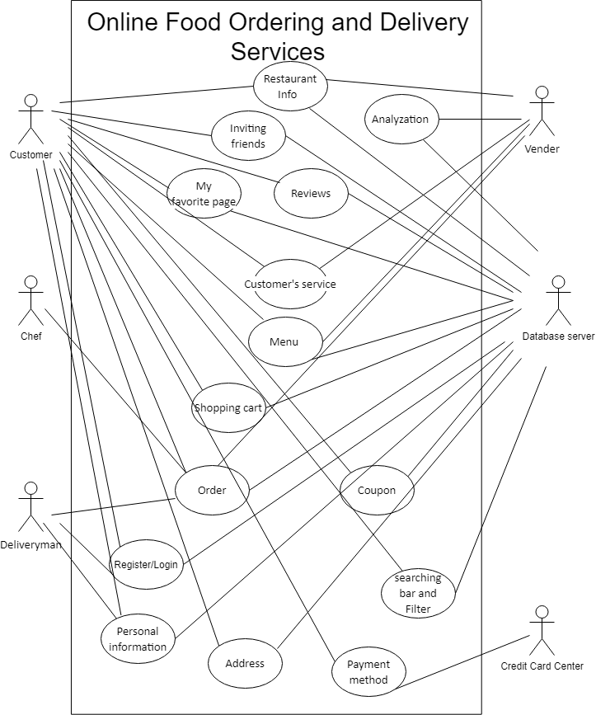

From the Use Case Diagram, you can see that there are six major actors of the online food ordering system: customer (a person), credit card center (an organization), database server (an external system), vendor (an organization), Chef (a person) and deliveryman (a person).

Assumptions:

* Analyzation: The analyzation can analysis the revenue of that month and stored in a centralized database server.
* Order: The orders are stored in a centralized database server which all the actor customers, deliveryman and vendor can see it.
* Register/ Login: The customers and deliveryman can register or login their own account and stored in database server.
* Payment method: The credit card payments are paid by customers and confirmed by credit center which the data will not store in the database.

**Normal scenario: Customer**

Ordering (5 steps)

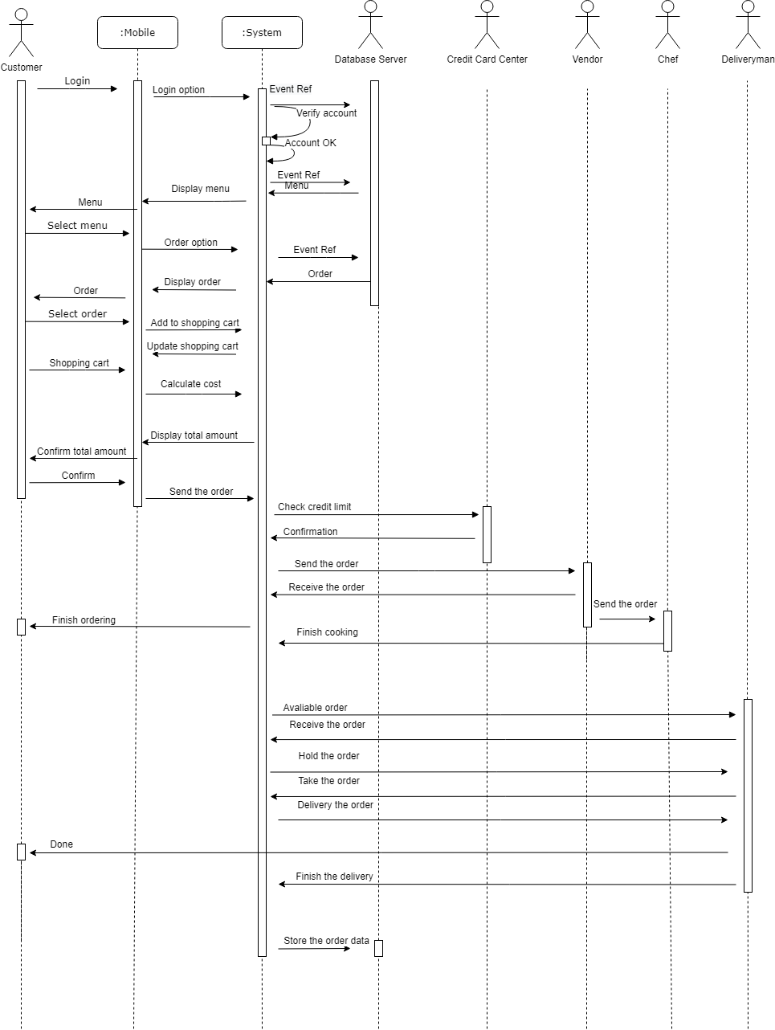

|  |  |
| --- | --- |
| Ordering (New user order) (7 steps) | Ordering with tracking and review |

Exceptional scenario of ordering

|  |  |
| --- | --- |
| Traffic jam problem | No ingredient |
| Exceptional scenario: Credit limit exceeded | Normal scenario of searching |

**Vender:**

|  |  |
| --- | --- |
| Normal scenario of analysis | Normal scenario (Vender management) |
| Normal scenario (Vendor: Accept order)    Normal scenario (Vendor: Cancel order) | Exceptional scenario: Fail order of Vender |

**Deliveryman:**

|  |  |
| --- | --- |
| Normal scenario | Exceptional scenario |

1. **User interface design of the system prototype**

|  |  |
| --- | --- |
| **Restaurant style**  We follow the restaurant menu to design the system. |  |

**Screen captures of the user-interface of the prototype**

**Customer: Instructions for guiding the users**

|  |  |  |  |  |  |
| --- | --- | --- | --- | --- | --- |
|  |  |  |  |  |  |
| English version | Chinese version | Login | Forget pw | Sign-in | Sign-up |
|  |  |  |  |  |  |
| Choose | Finish sign-in | Verification | Multi-function | Main | Person details |
|  |  |  |  |  |  |
| Cart noodle 1 | Cart noodle 2 | Menu | Payment | Tracking 1 | Tracking 2 |
|  |  |  |  |  |  |
| My favourite 1 | No my favourite | Location | Address | No address | Setting |
|  |  |  |  |  |  |
| Invite friend 1 | Invite friend 2 | Invite friend 3 | Searching 1 | Searching 2 | Review |
|  |  |  |  |  |  |
| Add Payment | Choose | No payment | View Payment | Info | CS 1 |
|  |  |  |  |  |  |
| CS 2 | No coupon | Coupon | Add coupon | Done coupon | View coupon |
|  |  |  |  |  |  |

|  |  |  |  |  |
| --- | --- | --- | --- | --- |
| No order | Recent order | Past order | Order detail | Review |
|  |  |  |  |  |
| Error Message | Error Message | Error Message |  | Order Confirm |
|  |  |  |  |  |

**Vender: Instructions for guiding the users**

|  |  |  |  |  |
| --- | --- | --- | --- | --- |
|  |  |  |  |  |
|  |  |  |  |  |

|  |  |  |  |  |  |
| --- | --- | --- | --- | --- | --- |
| Main Page | Management | Restaurant info | Time selector | Error message | News |
|  |  |  |  |  |  |
| Editing Menu 1 | Editing Menu 2 | Coupon list | Coupon detail | Date selector | Keyboard |
|  |  |  |  |  |  |
| Order | Order list | Order detail 1 | Order detail 2 | Order confirm | Error Message |
|  |  |  |  |  |  |
| Delivery order | Magnify | Delivering | Arrived | Done | Error Message |
|  |  |  |  |  |  |

|  |  |  |  |  |
| --- | --- | --- | --- | --- |
| Status | CS | Cancel order 1 | Cancel order 2 | Cancel order 3 |
|  |  |  |  |  |
| Analysis 1 | Analysis 2 | Analysis 3 | Analysis 4 | Analysis 5 |
|  |  |  |  |  |

**Chef:**

|  |  |  |  |
| --- | --- | --- | --- |
| List | Processing | Detail | Done |
|  |  |  |  |

**Deliveryman: Instructions for guiding the users**

|  |  |  |  |  |  |  |
| --- | --- | --- | --- | --- | --- | --- |
|  |  |  |  |  |  |  |

|  |  |  |  |  |  |  |
| --- | --- | --- | --- | --- | --- | --- |
| Multi Bar | Main Page | List 1 | List 2 | Accept 1 | Accept 2 | Detail |
|  |  |  |  |  |  |  |
| took | Delivered 1 | Delivered 2 | Delivered 3 | Contact | Waiting | Error msg 1 |
|  |  |  |  |  |  |  |
| Error msg 2 | Error order | Problem | Reward List | Reward 1 | Reward 2 | Personal info |
|  |  |  |  |  |  |  |

**Teamwork (timeline)**

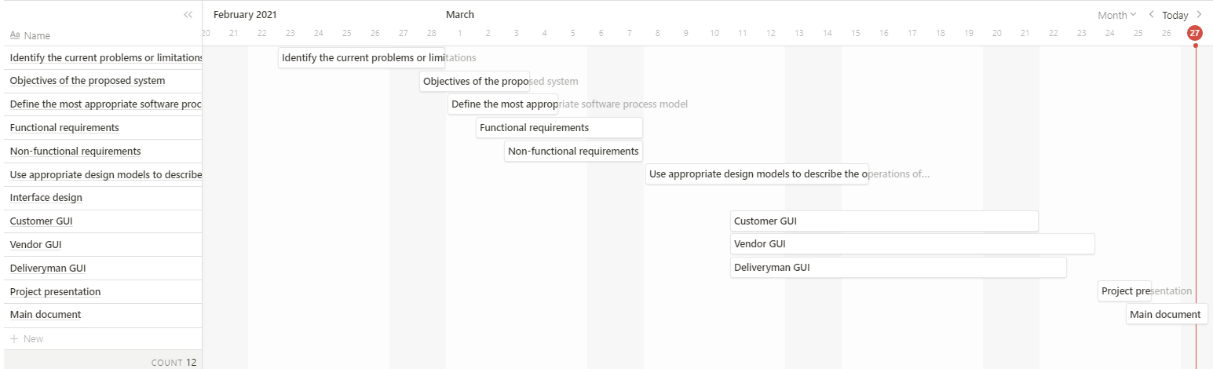

Distribution of work

Identify the current problems: CHEUNG Chung Yin, NG Ka Wah; Objectives of the system: NG Long Hin;

Functional requirements: All; Non-functional requirements: TSANG Kit Hong Andrew , WAN Sheung Yam

Define the most appropriate software process model: NG Ka Wah; System Design Specification: All

Interface design: Customer: NG Ka Wah, TSANG Kit Hong Andrew; Vendor: CHEUNG Chung Yin, NG Long Hin; Deliveryman: WAN Sheung Yam